**ESP8266 12E WiFi Module**

**Introduction:-**

The ESP8266 is a low-cost Wi-Fi chip with full TCP/IP stack and MCU (microcontroller unit)

capability produced by Shanghai-based Chinese manufacturer, Espressif Systems.

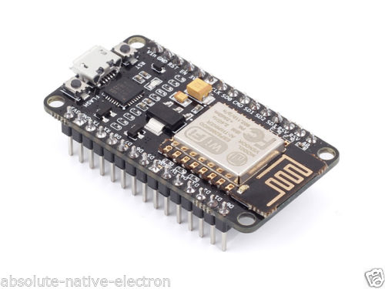

Fig No.3

**Specification:-**

Architecture 32-bit

RAM 128 KiB

ROM 4MB

ProcessingSpeed 80 MHz(Default) but can run on 160MHz

Wifi/Hotspot Yes/Yes

Micro usb Yes

Antina size 2mm

Table No. 2

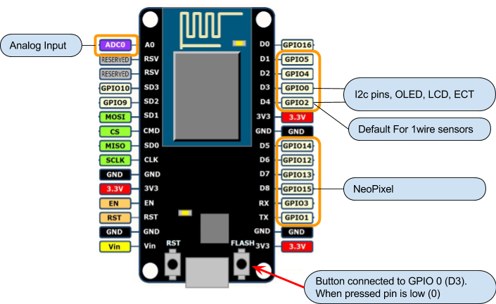

Fig No. 4

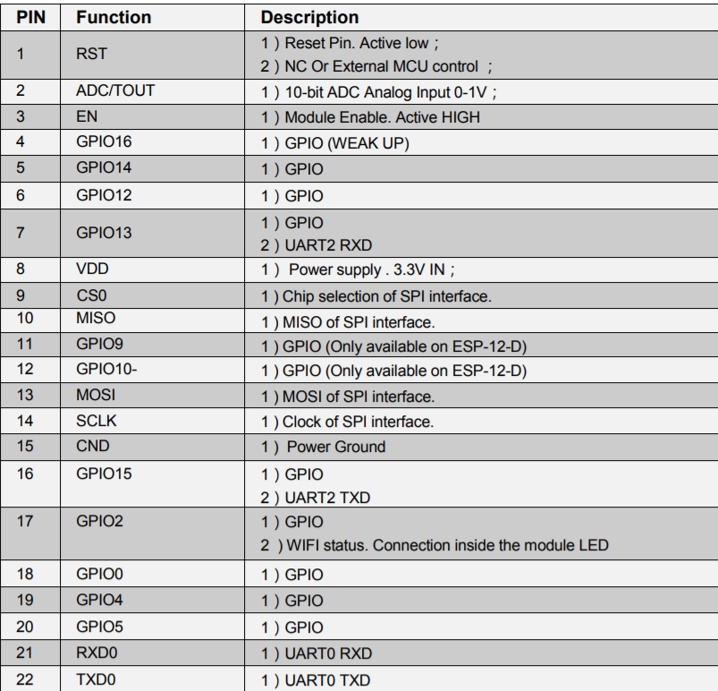

Table No.4